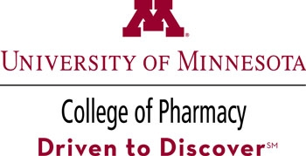

**College of Pharmacy Clinical Seminar Series**

**Announcement**

*“Entrepreneurship, Education, and Embracing the Digital Age in Healthcare”*

*Presented by:*

**

**Eric Christianson, PharmD, BCPS, CGP**

Owner of Med Ed 101 ([www.meded101.com](http://www.meded101.com))

Best-selling Amazon author and Originator/Podcaster, Real Life Pharmacology Podcast

**December 5, 2018**

3:30 - 4:30 PM

Duluth Campus 160 Life Sciences

Twin Cities Campus (via ITV) room TBD

Learning Objectives for this seminar include:

1. Understand how to leverage social media to develop an audience.

2. Recognize pitfalls and risks of engaging in online discussions.

3. Learn which tools are beneficial to maximize your online presence

This seminar is open to the public.

*“The University of Minnesota is an equal opportunity educator and employer.”*

|  |  |
| --- | --- |
|  | In support of improving patient care,**University of Minnesota, Interprofessional Continuing Education** is jointly accredited by the Accreditation Council for Continuing Medical Education (ACCME), the Accreditation Council for Pharmacy Education (ACPE), and the American Nurses Credentialing Center (ANCC) to provide continuing education for the healthcare team.   **Accreditation Council for Pharmacy Education** The Universal Activity Numbers is (COMING SOON). This **knowledge-based** activity has been approved for 1 contact hour.  **Other Health Professionals**  It is the responsibility of each participant to determine if the program meets the criteria for re-licensure or re-certification for their discipline. |